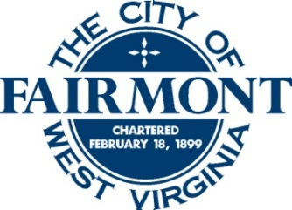

HISTORIC PRESERVATION REVIEW COMMISSION
Special Call Meeting
Monday, August 11, 2025
Public Safety Building
5:00 pm

- MEETING CALLED TO ORDER
- ROLL CALL OF MEMBERS
- APPROVAL OF MINUTES – May 5, 2025 & July 14, 2025
- ELECTION OF 2025 OFFICERS
- NEW BUSINESS
HPRC 25-02 – Dominic Maiden is applying for a Certificate of Appropriateness for window signs for their new business, K&D Daily Deals, at 115 Jackson Street.

HPRC 25-03 – Adam Rohaly on behalf of The Orange Goat LLC, is applying for a Certificate of Appropriateness at 200 Fairmont Avenue to regrade landscaping, repair some sections of retaining wall, and remove some sections of retaining wall.

HPRC 25-04 – Sydney Stansberry is applying for a Certificate of Appropriateness for window signs at 320 Adams Street for the American Job Center.
- OLD BUSINESS
None

- ADJOURNMENT

